G.AKCHAYADEVI(192524501)

CSA1519 CLOUD COMPUTING AND DATA ANALYTICS

4.Create a simple cloud software application for Library book reservation system for SIMATS library using any Cloud Service Provider to demonstrate SaaS.

Aim
To develop a simple cloud-based Library Book Reservation System using Zoho Creator as a Cloud Service Provider and to demonstrate the Software as a Service (SaaS) model for managing book reservation and student details.

Procedure
- Log in to Zoho Creator.
- Create a new application in Zoho Creator named Library Book Reservation System.
- Create a single form named Book Reservation Details with student, book, reservation, and payment fields.
- Configure suitable field types such as Name, Phone, Email, Single Line, Number, Date, and Drop Down.
- Add a simple workflow to limit the number of books that can be reserved.
- Enter sample student and book details, submit the reservation, and verify the records in the cloud application.

Implementation
The Library Book Reservation System was implemented using Zoho Creator as the cloud service provider. A single form named Book Reservation Details was created with fields such as student name, phone number, email, student ID, book title, author name, book ID, book category, reservation date, return date, number of books, book availability, reservation status, and payment status. Drop-down fields were used to select book category, availability, reservation status, and payment status. A simple workflow was implemented to restrict the maximum number of books that can be reserved. Sample student and book records were entered and tested using the cloud application.

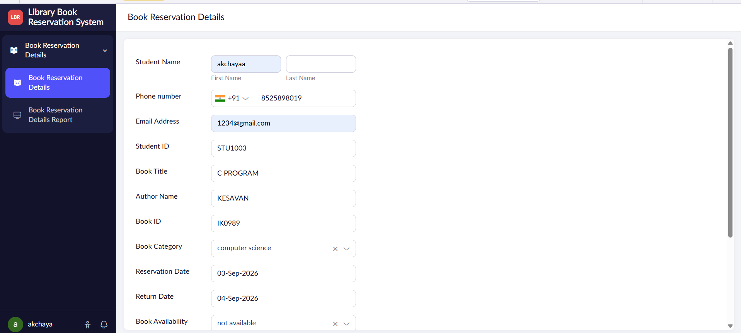

FIGURE 1:LIBRARY BOOK RESERVATION SYSTEM FORM

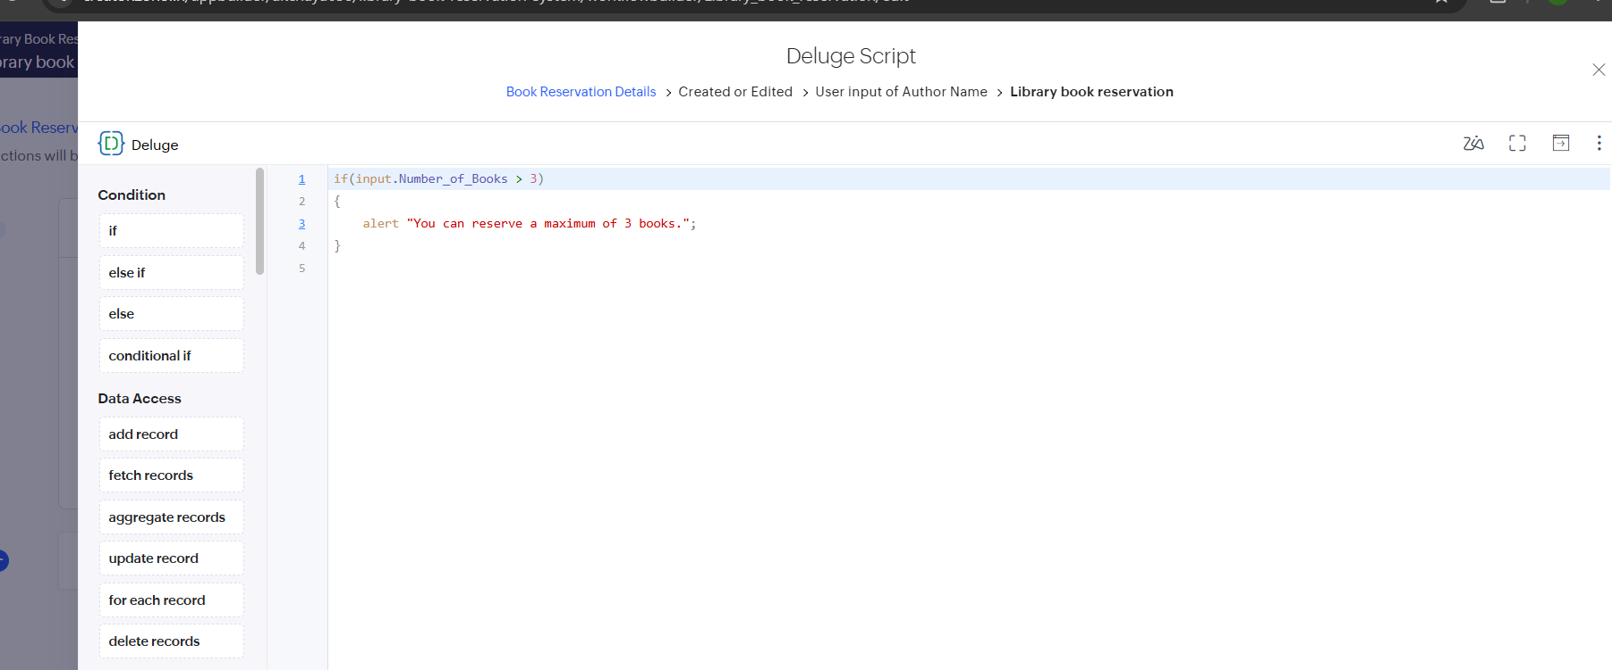
FIGURE 2: WORKFLOW

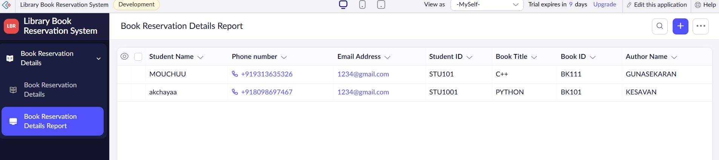
FIGURE 3 LIBRARY BOOKING RESERVATION SYSTEM REPORT

Result
Thus, the Library Book Reservation System was successfully developed using Zoho Creator. The application allows users to enter student and book details, reserve books, check availability, manage return dates, and maintain reservation status. The experiment successfully demonstrated the Software as a Service (SaaS) model using a cloud-based application.

